

Learn India Learn

A
Major Project Report
Submitted
In partial fulfillment
For the award of the Degree of
BACHELOR OF TECHNOLOGY
In the Department of Computer science and Engineering
Submitted by:
SEJAL JAIN
SHIVANGI DHARMAWAT

Department of Computer Science and Engineering
TECHNO INDIA NJR INSTITUTE OF TECHNOLOGY
RAJASTHAN TECHNICAL UNIVERSITY
May 2022

TECHNO INDIA NJR INSTITUTE OF TECHNOLOGY

CERTIFICATE

This is to certify that this project report “Learn India Learn” is the work of “Sejal Jain and Shivangi Dharmawat” who have carried out the project work under my supervision. I approve this project for submission of the Bachelor of Technology in the Department of Computer Science and Engineering, Techno India NJR Institute of Technology, affiliated to Rajasthan Technical University, Kota.

Mr. Aditya Maheshwari
Project In-charge
Department of Computer Science

ABSTRACT

1. Purpose

1.1. Introduction

This website is developed to enhance E-learning. Our digital learning ecosystem
ARGUS enables learning anytime, anywhere. Each child learns differently and has a unique learning style. ARGUS facilitates ‘personalized learning’ tailored to the distinctive learning style of each child. It enables learning, revision of concepts and cross-collaboration and project work. It acts as a connection between our educators and the Cerebrum Team. ARGUS enables our two pillars of teaching(our teachers and the Cerebrum team) to share blue-prints, summative papers, sample papers, syllabus, reflection, worksheet, lesson plans etc.
Parents and teachers can access students’ report at every stage, identify areas of improvement and work towards achieving them.

1.2. Scope

The scope of this application is to introduce new methods. The instructors will make online courses more interesting and engaging for learners. Apart from students, organizations are adapting to eLearning courses to train their employees.
This application will provide a means to interact with the students, parents and the teachers.

2. Document overview

The remainder of this document is 8 chapters, the first providing an introduction to the project. It lists all the functions performed by the system. The second chapter consists of software requirements specification. The third chapter provides details about system analysis and design. The fourth chapter gives data dictionary information. The fifth chapter consists of snapshots of the complete project. The sixth chapter gives testing for the project. The seventh chapter tells about the conclusion and future enhancements of the project. The final chapter concerns the bibliography.

ACKNOWLEDGEMENT

It gives me immense pleasure to express my deepest sense of gratitude and sincere thanks to my highly respected and esteemed guide Mr. Aditya Maheshwari (Project In-charge), TINJRIT for their valuable guidance, encouragement, and help in completing this work. Their useful suggestions for this whole work and cooperative behavior are sincerely acknowledged. At the end, I would like to express my sincere thanks to all my friends and others who helped me directly or indirectly during this project work.
I also wish to express my indebtedness to my parents as well as my family members whose blessings and support always helped me to face the challenges ahead.
At the end I would like to express my sincere thanks to all my friends and others who helped me directly or indirectly during this project work.

SEJAL JAIN
SHIVANGI DHARMAWAT

Udaipur, Rajasthan - 313001
30/05/2022

TABLE OF CONTENTS
Table of Contents
Abstract....................................................................................................................................... 3
Acknowledgment.........................................................................................................................5
Table of Contents ...................................................................................................................... 6
List of Symbols........................................................................................................................... 8
CHAPTER – 1 Introduction......................................................................................................9-12
Introduction ............................................................................................................................... 10
1.1.Purpose................................................................................................................................10
1.2.Overall Description ..............................................................................................................12
CHAPTER – 2 Software Requirement Specification ........................................................... 15-18
2.1. Purpose.............................................................................................................................. 15
2.2. Glossary.................................................................................................................……......17
CHAPTER – 3 System Analysis and Design ....................................................................... 19- 22
3.1. Study & Weaknesses of current system .............................................................................19
3.2 Requirements of new system .............................................................................................. 21
3.3. Feasibility Study ................................................................................................................. 21
3.4. Features of new System ..................................................................................................... 22
CHAPTER – 4 Data Dictionary ................................................................................................24-28
4.1. Data Elements ......................................................................................................................25
4.2. Data Structure .......................................................................................................................25
4.3 Table ………………………………………………………………………………………………… 26
4.4 E-R Diagram ………………………………………………………………………………………. 27-28
CHAPTER - 5 ScreenShots ..................................................................................................... 29-40
5.1. Dashboard.......................................................................................................................... 30
5.2. Modules .............................................................................................................................. 33
5.3. Registration. ........................................................................................................................34
5.4. Test………….......................................................................................................................36
5.5. LogOut ….. ........................................................................................................................ 40
CHAPTER – 6 Testing .............................................................................................................41-49
6.1. Testing Methodology........................................................................................................... 42
6.2. System Testing……............................................................................................................ 43
6.3. Program Testing.........................................................................................................……. 44
6.4. String Testing..................................................................................................................... 45
6.5. System Testing …………………………………………………………………………………..46
6.6. System Documentation..................................................................................................... 46
CHAPTER – 7 Conclusion and Future Enhancements ...................................................... 50- 52
7.1. Limitations .......................................................................................................................... 51
7.2. Future Enhancements ........................................................................................................ 51
7.3. Conclusion ......................................................................................................................... 51
CHAPTER – 8 Bibliography .................................................................................................... 52-53

List of Symbols
Term | Definition
User | The user who has the permission to insert or update category etc. in the database.
Field | Admin stored in the Database
React | Front-end Design Framework
QA | Quality assurance
SCMP | Software Configuration Management Plan
SDD | Software Design Document
SRS | Software Requirements Specification
Mongo | Cloud-hosted MongoDB service

CHAPTER – I
INTRODUCTION

1. Purpose

1.1.1 Introduction

This website is developed to enhance E-learning. Our digital learning ecosystem
ARGUS enables learning anytime, anywhere. Each child learns differently and has a unique learning style. ARGUS facilitates ‘personalized learning’ tailored to the distinctive learning style of each child. It enables learning, revision of concepts and cross-collaboration and project work. It acts as a connection between our educators and the Cerebrum Team. ARGUS enables our two pillars of teaching(our teachers and the Cerebrum team) to share blue-prints, summative papers, sample papers, syllabus, reflection, worksheet, lesson plans etc.
Parents and teachers can access students’ report at every stage ,identify areas of improvement and work towards achieving them.

1.1.2 Scope

The scope of this application is to introduce new methods. The instructors will make online courses more interesting and engaging for learners. Apart from students, organizations are adapting to eLearning courses to train their employees.
This application will provide a means to interact with the students, parents and the teachers.

1.1.3. Document overview

The remainder of this document is 8 chapters, the first providing an introduction to the project. It lists all the functions performed by the system. The second chapter consists of software requirements specification. The third chapter provides details about system analysis and design. The fourth chapter gives data dictionary information. The fifth chapter consists of snapshots of the complete project. The sixth chapter gives testing for the project. The seventh chapter tells about the conclusion and future enhancements of the project. The final chapter concerns the Bibliography.

This document is meant for describing all the features and procedures that were followed while developing the system. This document specially mentions the details of the project, how it was developed, the primary requirement, as well as various features and functionalities of the project, and the procedures followed in achieving these objectives.

This Web Application forms the lifeline of the Educational Institutes to the functioning of the Test and Modules. It is very essential for an organization to handle the users and their data. It is very useful for an organization to provide education to its users continuously for their development.

This website includes a homework and project assigning section where different types of homework are assigned to students to improve their self-learning capability.

1.2 Overall description
This is an E-Learning website which includes various functionalities like providing live classes, digital textbooks, frequent online quizzes and assessments, concept and subject-wise revision, real time performance tracking and analytics.
It also provides monitoring of performance of students by educators, admin and management team.
There is a parent app also which provides functionality to parents to track their children’s performance report and evaluated assessment keys, progress information in the form of graph and pie-chart.

1.2.1. Functional requirements definitions
Functional Requirements are those that refer to the functionality of the system, i.e., what services it will provide to the user. Nonfunctional (supplementary) requirements pertain to other information needed to produce the correct system and are detailed separately.

1.1.1. Use cases
This system will be used by Three type of Users: Student, Teacher, and Parents. All of them have different requirements, the modules are designed to meet their needs and avoid any type of confusion. The Uses of the application are described below.
[1] User can do the following functions:-
- Register(Add Details)
- Login to the account
- Check Progress
- About Organization
- Logout

[2] User can do the following functions in the Student Module:
- Give Test and Homework
- View Result
- Learn from PDF
- Learn from Videos

[3] User can do the following functions in the Parent Module:
- View Student Progress
- Upload Queries
- Check Status of Assignments

[4] User can do the following functions in the Teacher Module:
- Assign Homework
- Assignment Evaluation
- Release Paper
- Lock and Unlock Student from Assesment

1.1.2. User characteristics
The user should be familiar with English Language. The user should be familiar with the Websites.

1.1.3. Constraints
There is no person to person interaction between students, teachers and parents.
Cheating prevention during online assessments is complicated.
It can cause Social Isolation.

CHAPTER – II
Software Requirement Specification

System Analysis and Design

3.1. Study & Weaknesses of Current System
The Current system of application is highly complicated and expensive. Whenever tests are to be conducted there are various tasks that have to be done again and again.
- Setting questions.
- Checking for errors
- Scheduling Answers
- Checking Answers
- Evaluating Assessments
- Solving Question Papers
- Uploading Answer Sheets
- Release Answer Sheets

Weaknesses in Current System

The current system is as mentioned earlier very complicated and expensive as compared to the new system. It also wastes the precious time of the faculties.

As Faculties are humans and so prone to errors, there can be mistakes in checking answer papers, calculating marks and the result charts prepared may also have these errors. Only preventive measures are taking a double check to ensure these errors don’t happen which would again require extra time and may also result in a mentally tired faculty.
Thus, the current system is in every way ineffective for conducting examinations in these days when time is more costly than anything.

3.2. Requirements of New System
3.2.1. User Requirements
The User requirements for the new system are to make the system fast, flexible, less prone to errors and reduce expenses and save time.
· Time can be saved in scheduling the faculty's time.
· A system that can automate the checking of answers which are pre-stored so that results can be generated as soon as the student gives the exam.
· The system should have user and Faculty records on hand which can be used as per required only by authorized personnel.
· Finally, it should prove cost effective as compared to the current system.

3.3. Feasibility Study
A key part of the preliminary investigation that reviews anticipated costs and benefits and recommends a course of action based on operational, technical, economic, and time factors. The purpose of the study is to determine if the system's request should proceed further.

3.4. Features of the New System.
The new system has been designed as per the user requirements so as to fulfill almost all them.
Quick Scheduling
Exams can be created very quickly as compared to the existing system as it allows the use of previously entered questions to be used again. It saves time required to get the question papers printed and distributed before the students are allowed to appear for the examination. Questions entered once can be accessed by students as soon as they login to their account.
Immediate Results and Solutions
One of the most important drawbacks of the current system is that the faculties are required to check the answer papers which is again a lengthy process and prone to errors. The new system will generate the result as soon as the test is finished by the user and will also store it in the database for further usage. The solution is also available as soon as the questions are inserted in the database.

Easy to Store and Retrieve Information
The new system makes it easy to store and retrieve information as required and does not involve storing information in separate sheets or papers. It thus saves data management problems faced in the current system as it has a Database Management System.

Cost Effective
One of the main reasons for the new system is its cost effectiveness. It saves the amount spent on stationary as well as overall cost of conducting an examination which also involves paying supervisors, paper checkers, question paper printers etc.

CHAPTER – IV
DATA DICTIONARY

A data dictionary is a catalog-a-repository of the elements in a system. As the name suggests, their elements center on data and the way they are structured to meet user requirements and organization needs. In a data dictionary, you will find a list of all the elements composing the data flowing through a system. The major elements are data flows, data stores, and processes. The data dictionary stores details and descriptions of these elements.

If analysis wants to know characters are in a data item by what other names it is referenced in the system, where it is referenced in the system, or where it is issued in the system, they should be able to find the answers in issued in the system, they should be able to find the answer in the properly developed data dictionary.

The Dictionary contains two types of descriptions for the data following through the system.

1. Data Elements

The most fundamental data is the elements. They are building blocks for all other data in the system. Data elements are also alternatively known as fields, data items or elementary items.

2. Data Structure

A data structure is a set of items that are related to one another and describe components in the system.

3.Table Details

Field Name | Description | Constraints | Size | Data Type
Username | Name of the user |  | 50 | Text
Mobile Number | Act as password |  | 50 | Number

4. E-R Diagram

- Teacher :

M Main Activity

Login / Register Activity

Dashboard Activity
Assign Homework
Assign A ssessment

Project Type Exam Type Lock Student Unlock Student

Evaluate

Give Marks

Release
Publish Marks

Logout

- Student :

M Main Activity

Login / Register Activity

Dashboard Activity

Submit Homework/Assessment

View Marks

Logout

CHAPTER – V
SCREEN SHOTS

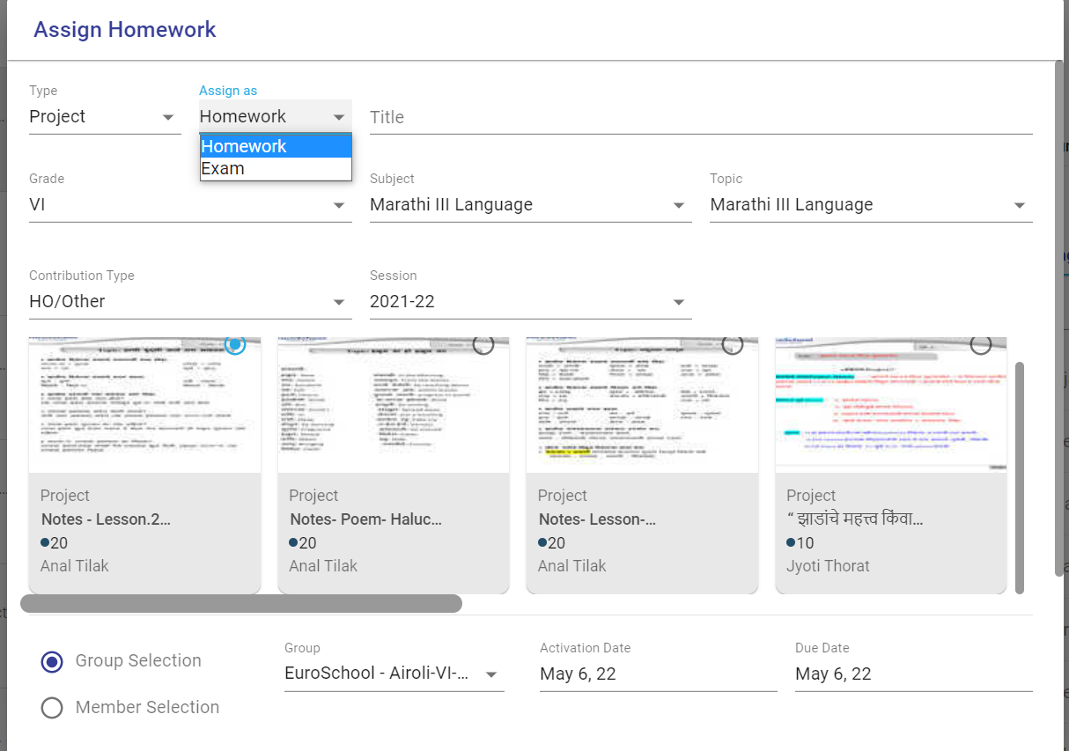
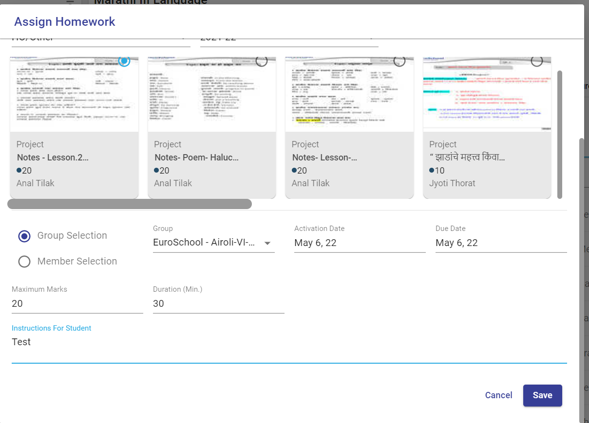
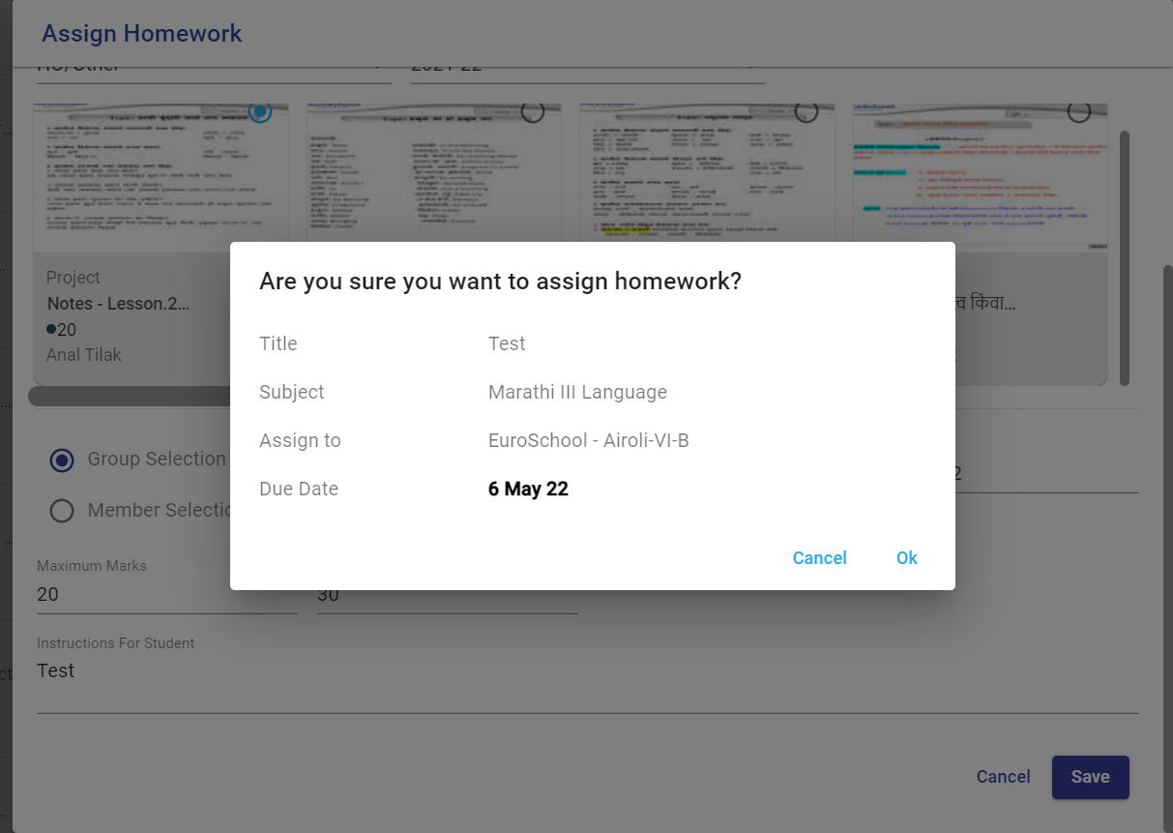
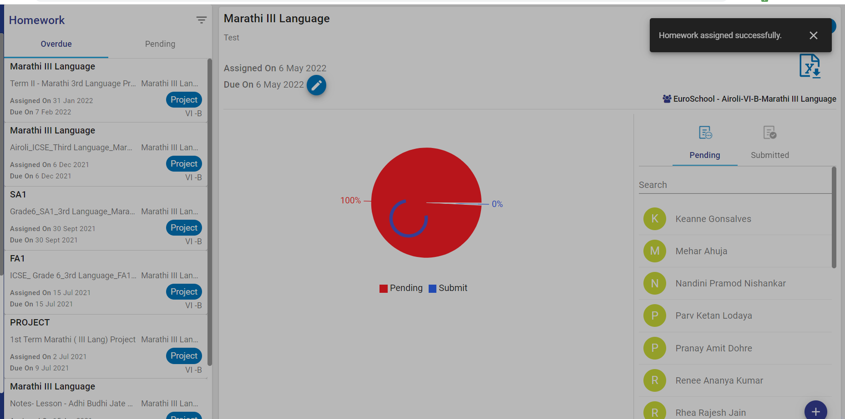

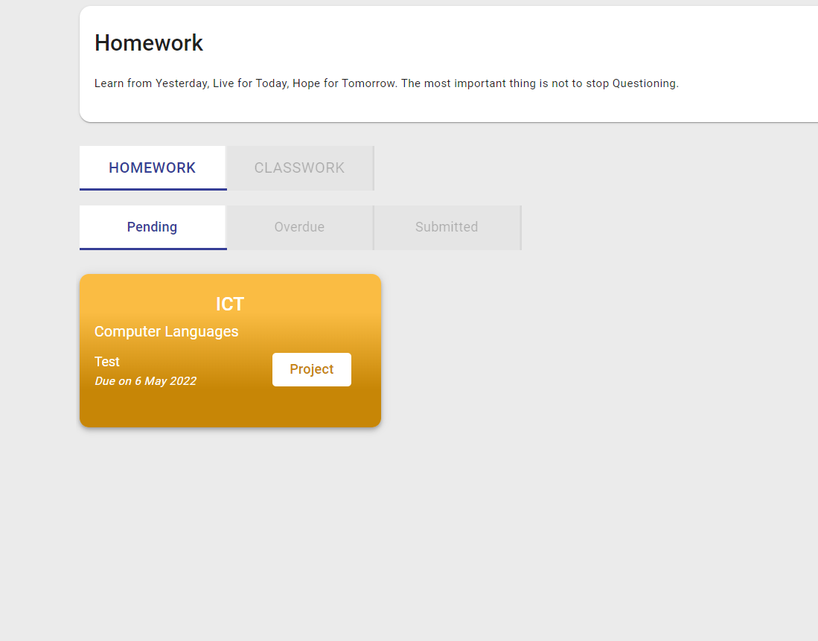
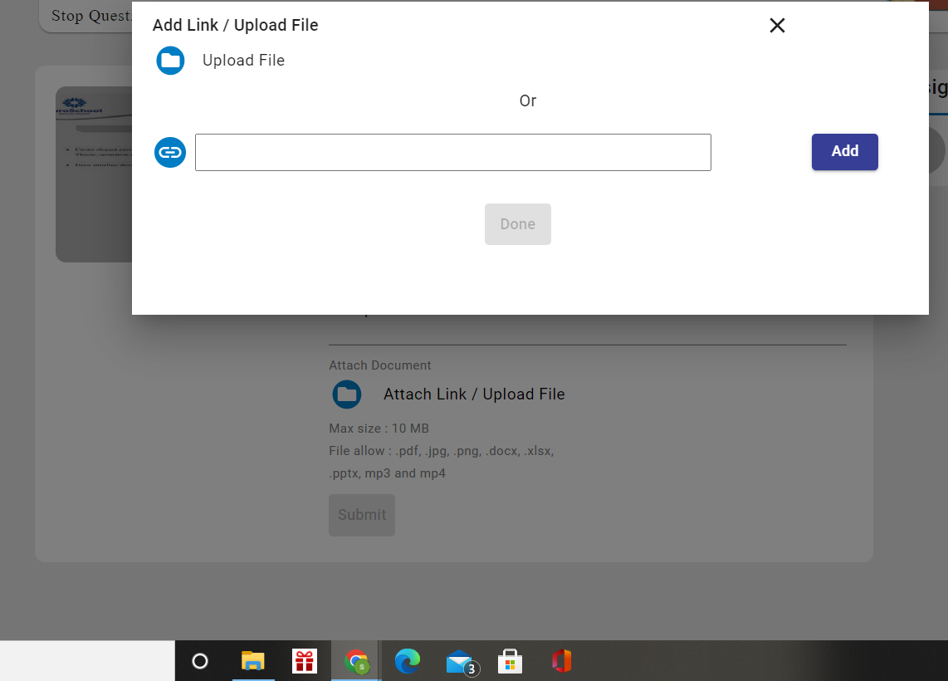
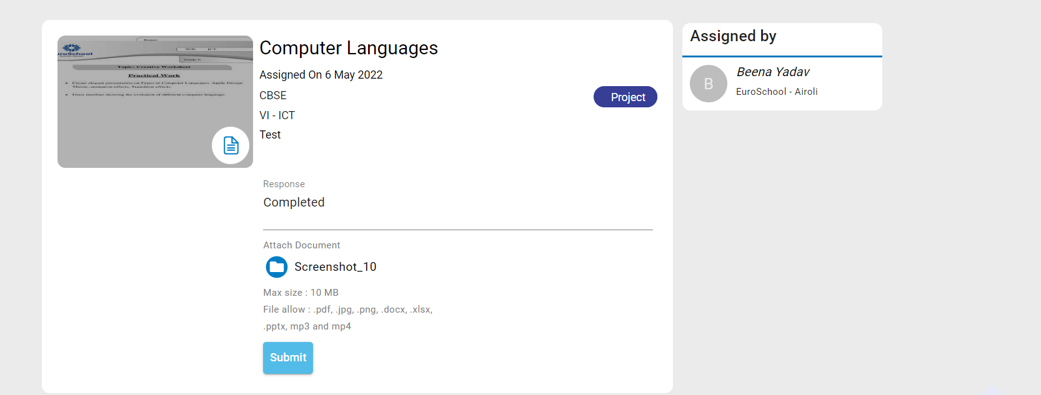
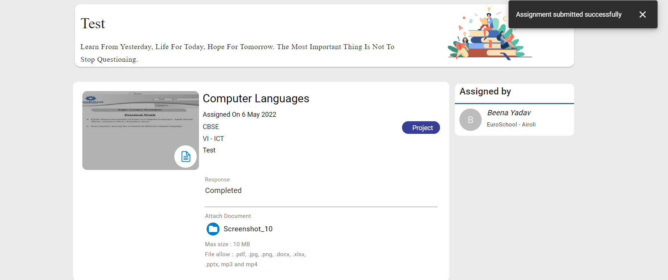
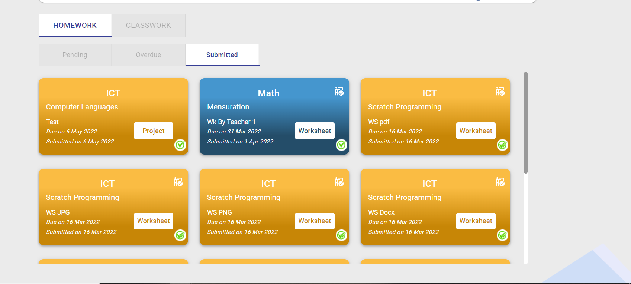
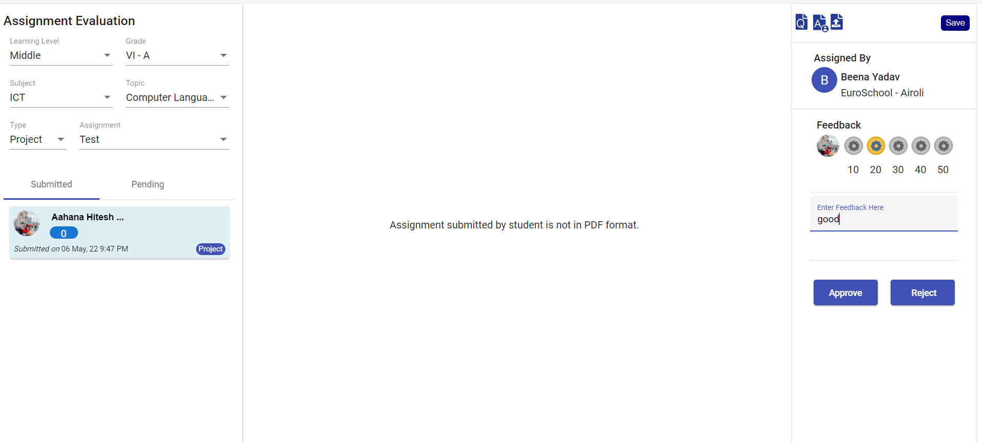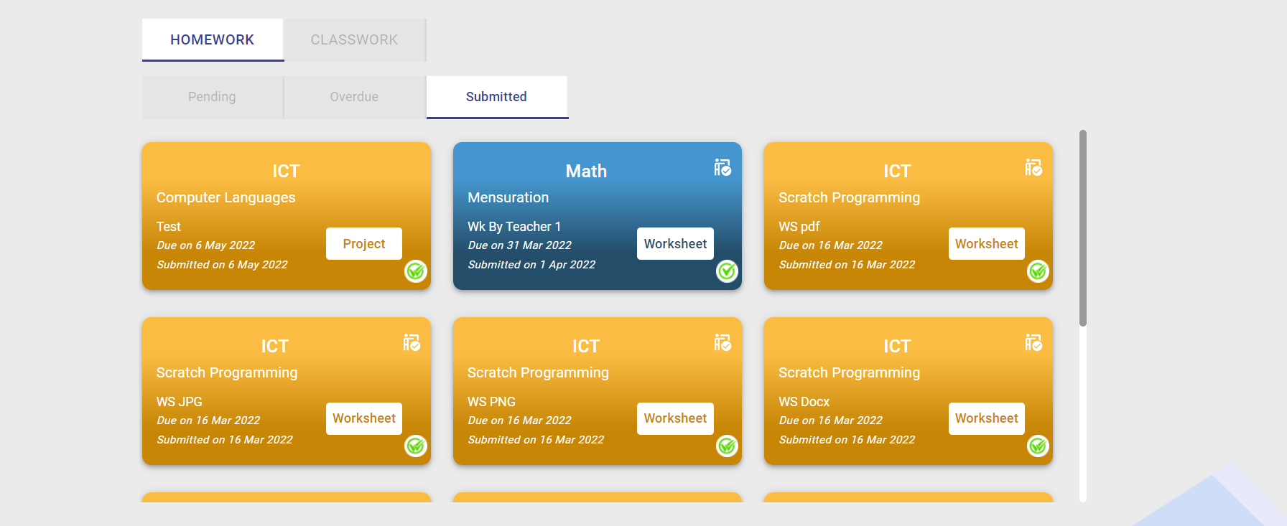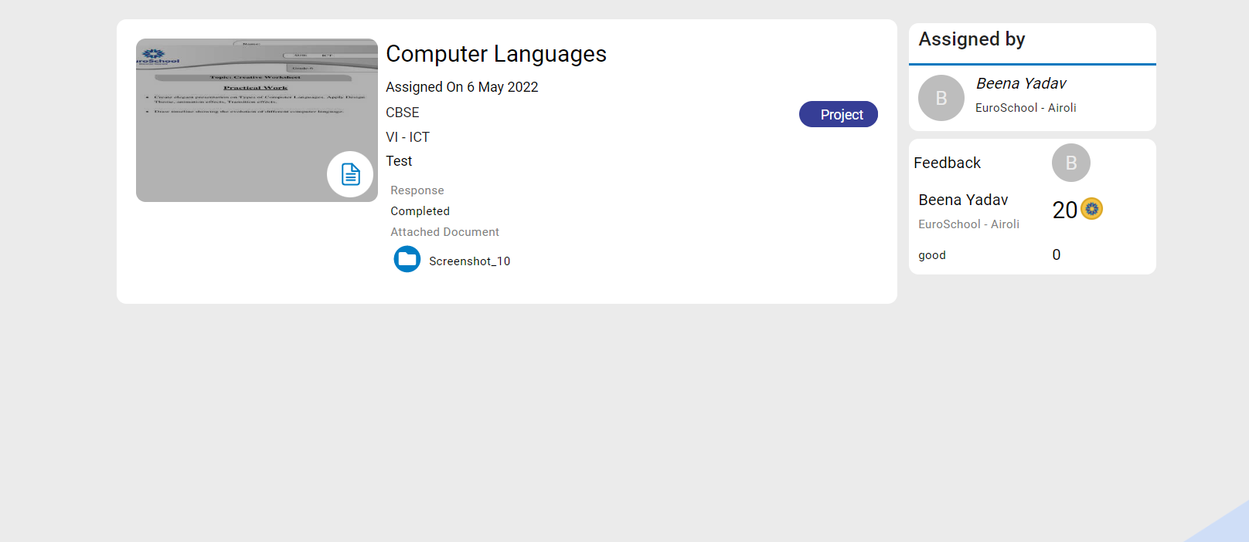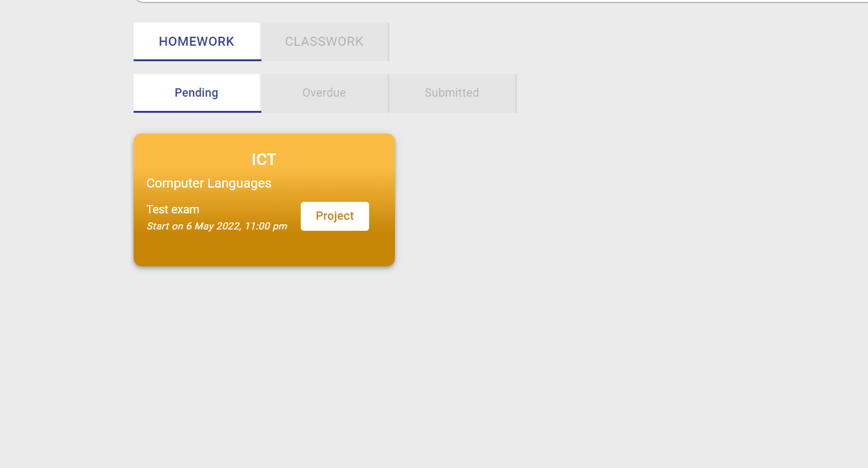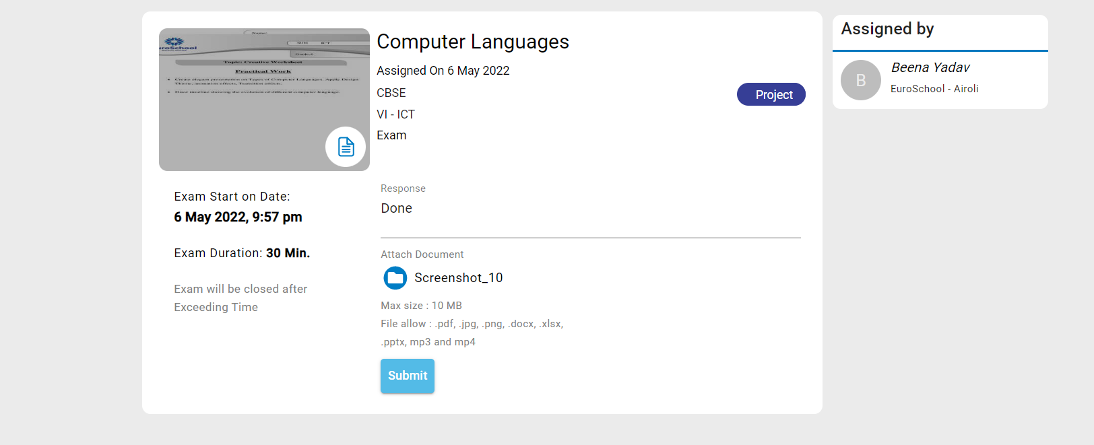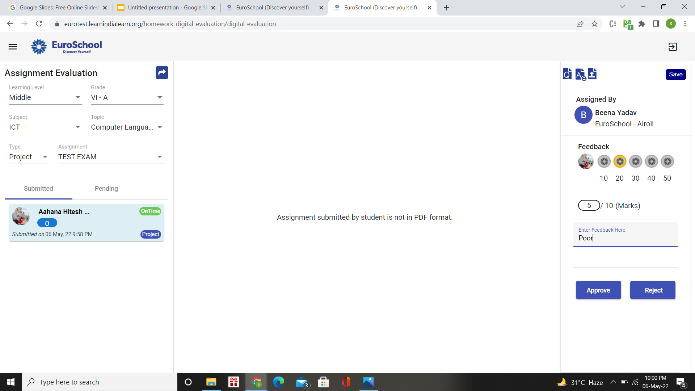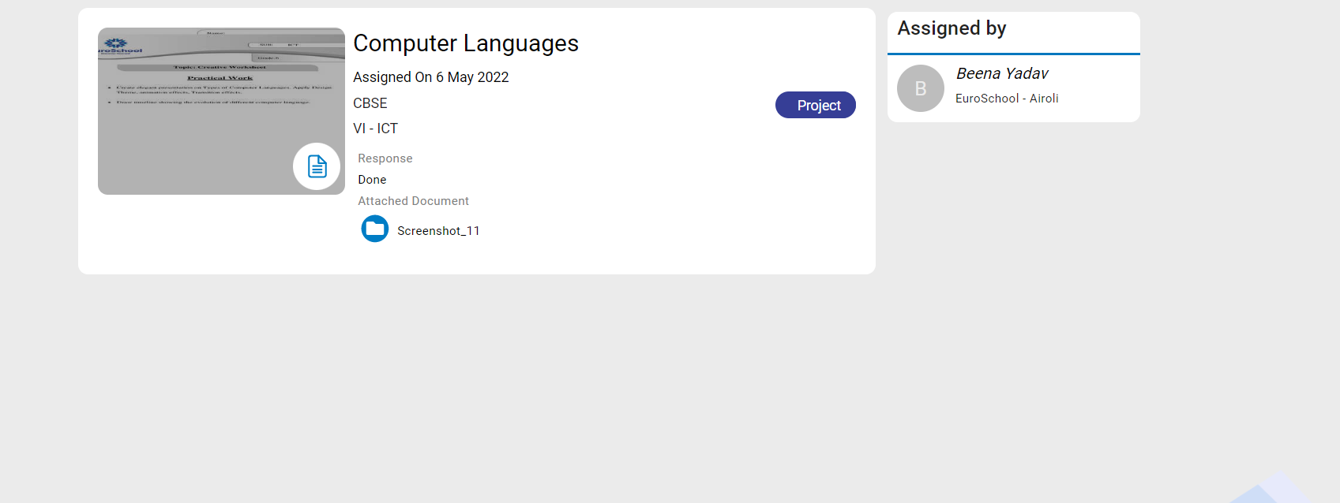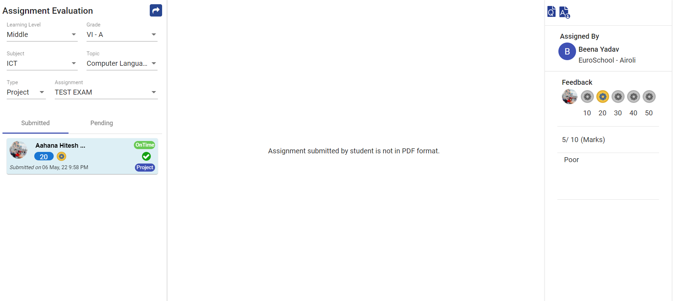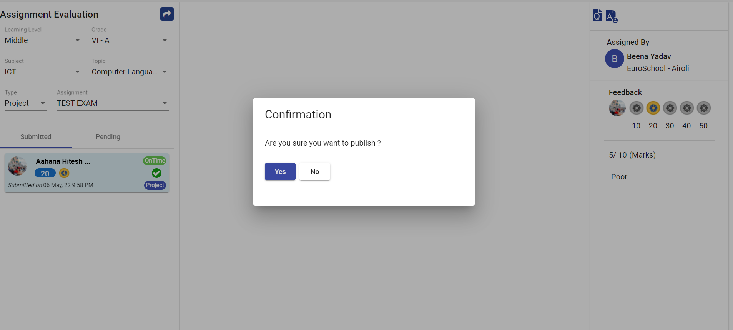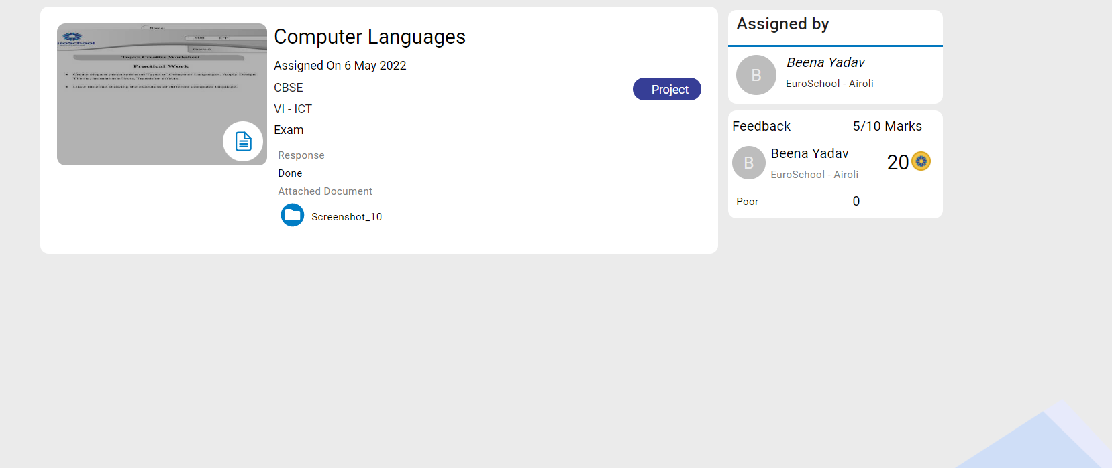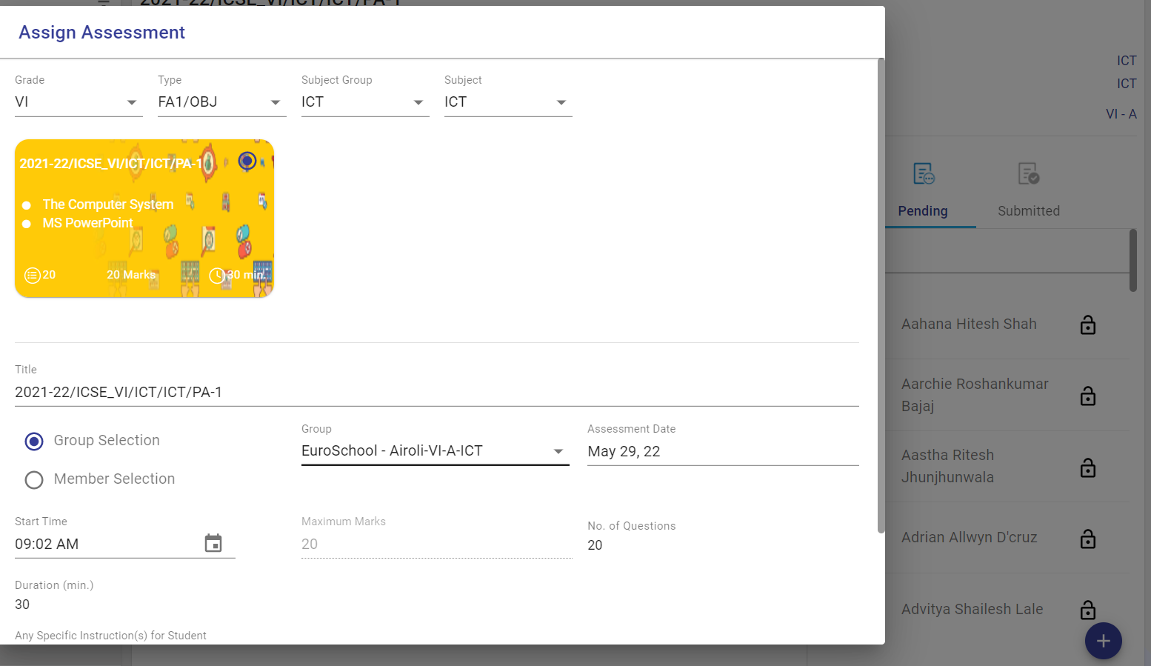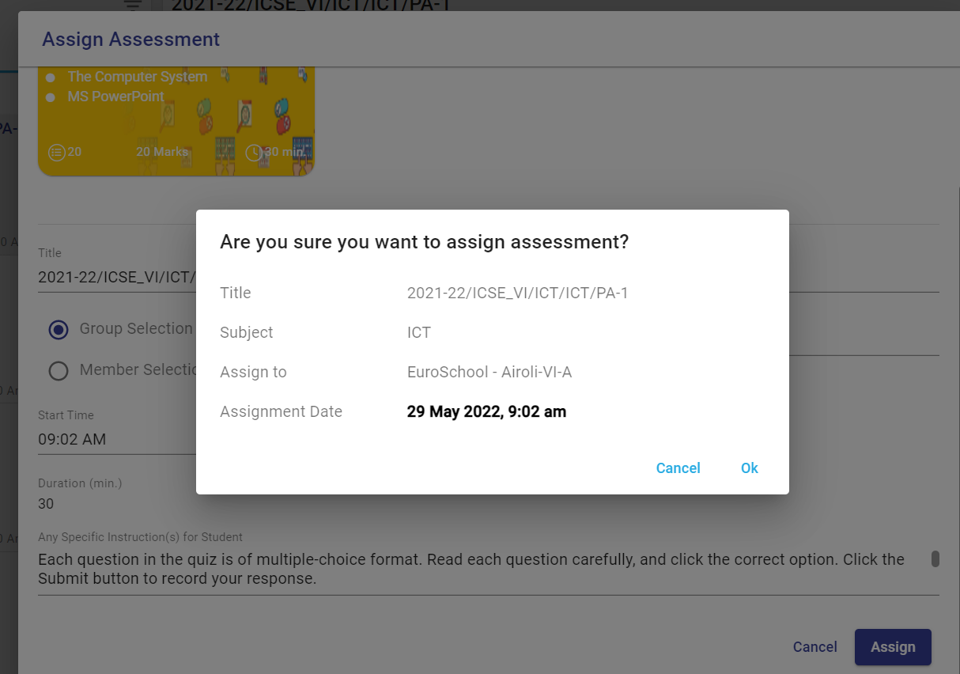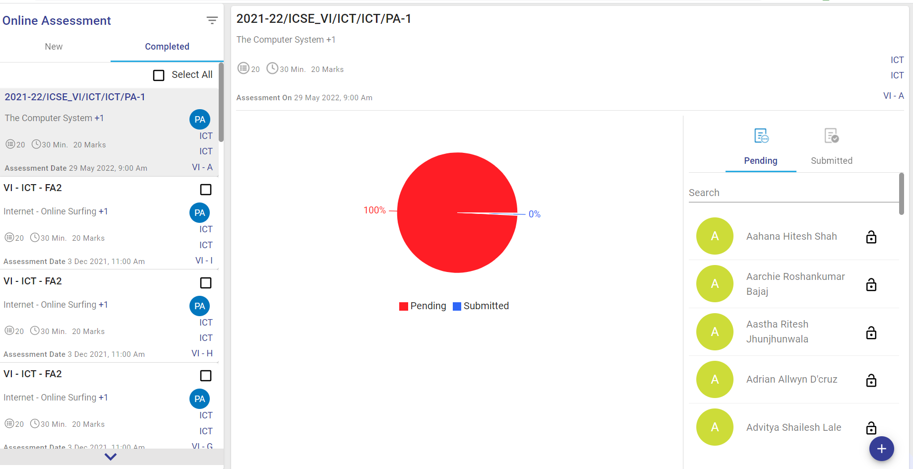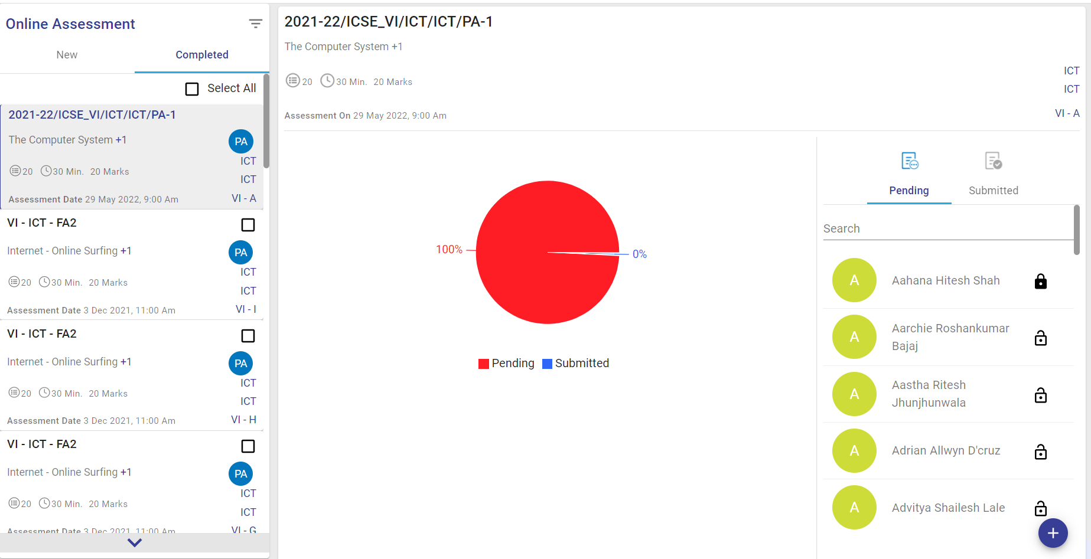

CHAPTER – VI
TESTING

Testing Methodology

Companies rely on software more than ever to provide and manage information with strategic and operational importance and to provide key decision support. Rising customer expectations for fault-free, requirements-exact software have increased awareness of the importance of software testing as a critical activity.

We begin the testing process by developing a comprehensive plan to test the general functionality and special features on a variety of platform combinations. Strict quality control procedures are used. The process verifies that the application meets the requirements specified in the system requirements document and is bug free. At the end of each testing day, we prepare a summary of completed and failed tests. Applications are not allowed to launch until all identified problems are fixed. A report is prepared at the end of testing to show exactly what was tested and to list the final outcomes.

Our software testing methodology is applied in three distinct phases: unit testing, system testing, and acceptance were testing.

Unit Testing: The programmers conduct unit testing during the development phase. Programmers can test their specific functionality individually or with other units. However, unit testing is designed to test small pieces of functionality rather than the system as a whole. This allows the programmers to conduct the first round of testing to eliminate bugs before they reach the testing staff. In unit testing the analyst tests the programs making up a system. For this reason, unit testing is sometimes called program testing. Unit testing gives stress on the
modules independently of one another, to find errors. This helps the tester in detecting errors in coding and logic that are contained within that module alone. The errors resulting from the interaction between modules are initially avoided.
For example, a hotel information system consists of modules to handle reservations; guest checking and checkout; restaurant, room service and miscellaneous charges; convention activities; and accounts receivable billing. For each, it provides the ability to enter, modify or retrieve data and respond to different types of inquiries or print reports. The test cases needed for unit-testing should exercise each condition and option. Unit testing can be performed from the bottom up, starting with smallest and lowest-level
modules and proceeding one at a time. For each module in bottom-up testing a short program is used to execute the module and provides the needed data, so that the module is asked to perform the way it will when embedded within the larger system.

System Testing: The objective of system testing is to ensure that all individual programs are working as expected, that the programs link together to meet the requirements specified and to ensure that the computer system and the associated clerical and other procedures work together. The initial phase of system testing is the responsibility of the analyst who determines what conditions are to be tested, generates test data, produces a schedule of expected results, runs the tests and compares the computer produced results with the expected results with the expected results. The analyst may also be involved in procedures testing. When the analyst is satisfied that the system is working properly, he hands it over to the users for testing. The importance of system testing by the user must be stressed. Ultimately it is the user must verify the system and give the go-ahead. During testing, the system is used experimentally to ensure that the software does not fail, i.e., that it will run according to its specifications and in the way users expect it to. Special test data is input for processing (test plan) and the results are examined to locate unexpected results. A limited number of users may also be allowed to use the system so analysts can see whether they try to use it in unexpected ways. It is preferable to find these surprises before the organization implements the system and depends on it. In many organizations, testing is performed by persons other than those who write the original programs.
Using persons who do not know how certain parts were designed or programmed ensures more complete and unbiased testing and more reliable software.
The system is tested as a complete, integrated system. System testing first occurs in the development environment but eventually is conducted in the production environment. Functionality and performance testing are designed to catch bugs in the system, unexpected results, or other ways in which the system does not meet the stated requirements. The testers create detailed scenarios to test the strength and limits of the system, trying to break it if possible. Editorial reviews not only correct typographical and grammatical errors but also improve the system’s overall usability by ensuring that on-screen language is clear and helpful to users. Accessibility reviews ensure that the system is accessible to users with disabilities.
System testing consists of the following five steps:
i. Program testing
ii. String testing
iii. System testing
iv. System documentation
v. User acceptance testing

Program Testing

A program represents the logical elements of a system. For a program to run satisfactorily, it must compile and test data correctly and tie in properly with other programs. It is the responsibility of a programmer to have an error free program. At The time of testing the system, there exist two types of errors that should be checked. These errors are syntax and logic. A syntax error is a program statement that violates one or more rules of the language in which it is written. An improperly defined field dimension or omitted key words are common syntax errors.
These errors are shown through error messages generated by the computer. A logic error, on the other hand, deals with incorrect data fields out of range items, and invalid combinations. Since the logical errors are not detected by the compiler, the programmer must examine the output carefully to detect them. When a program is tested, the actual output is compared with the expected output. When there is a discrepancy, the sequence of the instructions must be traced to determine the problem. The process is facilitated by breaking the program down into self-contained portions, each of which can be checked at certain key points.

String Testing

Programs are invariably related to one another and interact in a total system. Each program is tested to see whether it conforms to related programs in the system. Each part of the system is tested against the entire module with both test and live data before the whole system is ready to be tested.

System Testing

System testing is designed to uncover weaknesses that were not found in earlier tests. This includes forced system failure and validation of total system as it will be implemented by its user in the operational environment. Under this testing, generally we Take low volumes of transactions based on live data. This volume is increased until the maximum level for each transaction type is reached. The total system is also tested for recovery and fallback after various major failures to ensure that no data are lost during the emergency. All this is done with the old system still in operation. When we see that the proposed system is successful in the test, the old system is discontinued.

System Documentation
All design and test documentation should be well prepared and kept in the library for future reference. The library is the central location for maintenance of the new system.

User Acceptance Testing
An acceptance test has the objective of selling the user on the validity and reliability of the system. It verifies that the system's procedures operate to system specifications and that the integrity of important data is maintained. Performance of an acceptance test is actually the user's show. User motivation is very important for the successful performance of the system. After that, a comprehensive test report is prepared. This report shows the system's tolerance, performance range, error rate and accuracy.

Table 6.1 Test Report with test data
TEST REPORT WITH TEST DATA
(To be filled by System Analyst/Programmer)
Project Name: Learn India Learn

A. | INTERFACE TESTING  1) User-friendliness  2) Consistent menus | OK  OK
B. | CONTROL FLOW TESTING  1) IF-THEN-ELSE  2) DO WHILE  3) CASE-SWITCH | OK  OK  OK
C. | VALIDATION TESTING  1) Check for improper or inconsistent typing  2) Check for erroneous initialization or default values  3) Check for incorrect variable names  4) Check for inconsistent Data Types  5) Check for relational/arithmetic operators | OK  OK  OK  OK  OK
D. | DATA INTEGRITY/SECURITY TESTING  1) Data Insertion/ Deletion/ Updating  2) Boundary condition (Underflow, Overflow Exception)  3) Check for unauthorized access of data  4) Check for data availability | OK  OK  OK  OK
E. | EFFICIENCY TESTING  1) Throughput of the system  2) Response time of the system  3) Online disk storage required by the system  4) Primary memory required by the system | OK  OK  OK  OK
F. | ERROR HANDLING ROUTINES  1) Error description are intelligent/ understandable  2) Error recovery is smooth  3) All error handling routines are tested and executed at least once | OK  OK  OK

CHAPTER – VII
CONCLUSION AND FUTURE ENHANCEMENTS

7.1 Limitations:

The new system has been designed to meet almost all of the user requirements but it too has certain limitations some of which can be enhanced in the future enhancements or updates.

7.2 Future enhancements:

Enhancements are the perquisite for development of a system. Every existing system has proposed enhancements which make it better and easier to use and more secure. The enhancements that have been proposed for this system are listed here.

7.2.1 Availability on Different Platforms :
The new system will be available on different platforms such Mac, ios, Linux, etc.

7.3 Conclusion:
It is an web application for learning purpose. By the development of this web application, we will get a clear understanding of overall process of the system. The design of this Web Application requires elaborate design of all activities, by adopting React + JavaScript language as technical support of this system, with the Database which will lead to the comprehensive and smooth design and development of the Web Application.

CHAPTER – VIII
BIBLIOGRAPHY

References and Bibliography:

List of useful Websites:
React.js: https://reactjs.org/
MongoDB: https://docs.mongodb.com/
Node.js: https://nodejs.org/en/docs/
Angular: https://angular.io/docs

